Harvard Lecture Helper

User Guide/Documentation

Developed by Adam Atanas, Promit Ghosh, Wei-Te Mark Ting

Contents

Introduction 2

How to Install Harvard Lecture Helper 2

Using Harvard Lecture Helper 2

Main Menu 2

Notepad 3

Saving/Downloading Notes 4

Uploading Notes 5

CS50 2x 6

Video Manipulator 6

Video Pauser 6

Video Resumer 6

Supported Sites 6

Options 7

Known Limitations/Errors 7

Updated as of December 2014. Harvard Lecture Helper version 0.7.0 (beta)

Powered by Summernote and CS50!

# Introduction

Harvard Lecture Helper is an installable Chrome extension to help you take notes on lecture videos or recordings.

Harvard Lecture Helper consists of three primary components:

* A rich-text notepad supporting hyperlinks and embedding.
* CS50 2x Runtime (Thanks David!)
* Video controller with the ability to export timestamps (more on that later!)

# How to Install Harvard Lecture Helper

To use Harvard Lecture Helper, first install it from the Chrome extension store.

Developer Instructions:

1. First, unzip **HarvardLectureHelper.zip** to any directory (preferably somewhere you can find it again!)
2. Open up Google Chrome and go to [**chrome://extensions**](chrome://extensions)
3. Make sure that the **Developer mode** check box is checked
4. Click **Load unpacked extension…** and browse to where you unzipped **HarvardLectureHelper** earlier
5. Click **OK** to load the extension!

# Using Harvard Lecture Helper

## Main Menu

When you first click on the Harvard Lecture Helper extension button, you’ll see the **Main Menu** popup.

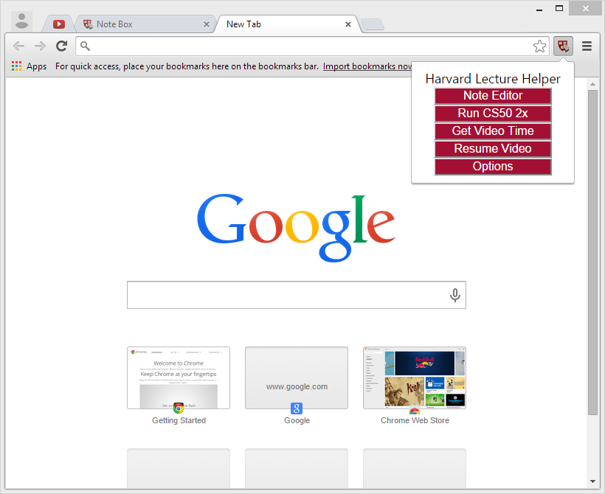

Figure 1: Main Menu Popup

From here, you can use any of the many functions that the Helper has to offer, as well as choose to set Options.

## Notepad

The Notepad appears in a newly opened Chrome window. At first glance, you will see that there is a **Save Notes** button above the **Editor**. Disregard that for now.

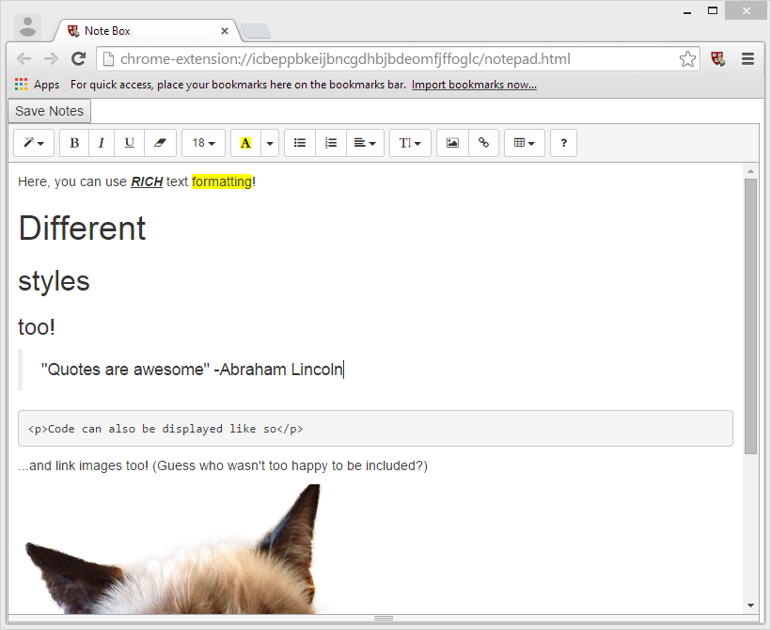

Figure 2: Notepad Window

The **Editor** has its own text formatting menu, replete with options from Header Styling, to Inserting Pictures, Hyperlinks, and creating Tables. There is also a handy **Help (?)** button for common keyboard shortcuts.

C:\Users\Operator\AppData\Local\Microsoft\Windows\INetCache\Content.Word\Notepad Editor Menu.png

Figure 3: Editor Formatting Menu

### Saving/Downloading Notes

If you’re say, an aspiring artist or diligent student, one of the worst things that could happen to you is losing your notes. **Save Notes** will keep a copy “alive” within your browser, so you can safely close the notepad window and open it later. However, clearing your browser cache will cause you to lose your notes, much like the **Clear Data** option (mentioned later!). To avoid this, or to work on multiple notes, you can **Download** your current set of notes.

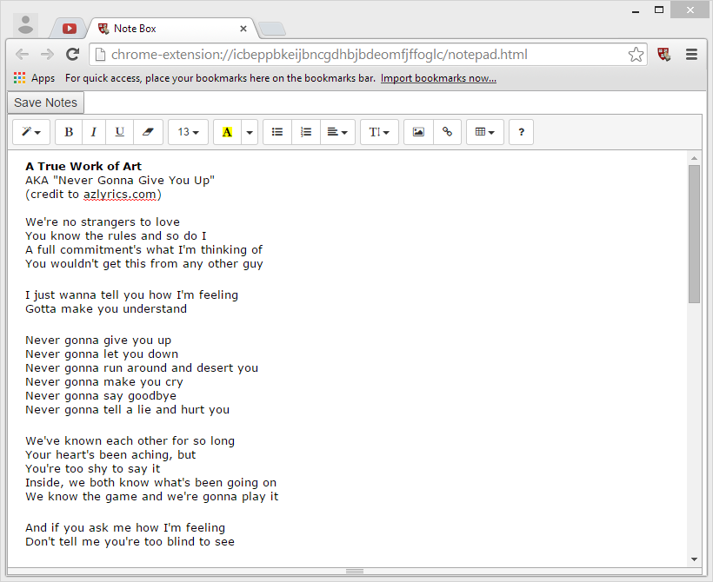

Figure 4: Save Notes

Clicking on the **Save Notes** button will cause the editor to disappear and new options to appear.

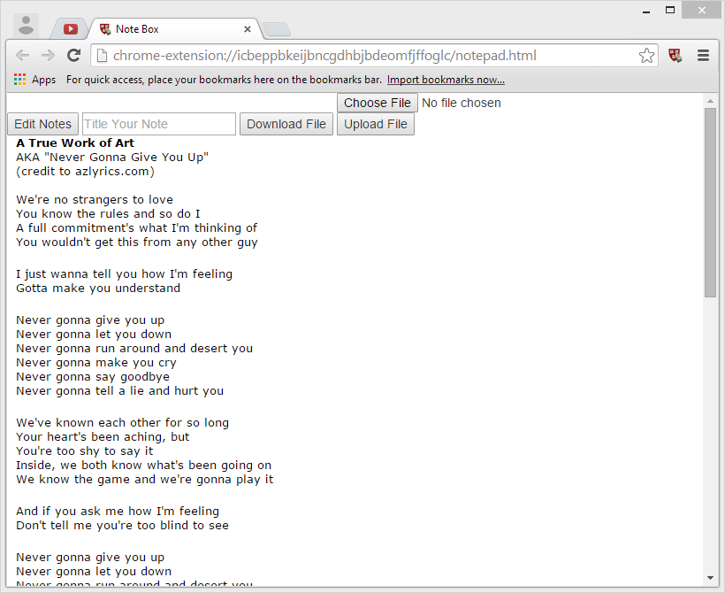

Figure 5: Save Menu

As you will see, there are a few new options:

* **Title Your Note** and **Download File**
* **Choose File** and **Upload File**

Title your note however you would like and hit **Download File** to save a named backup copy of your notes! (Note: this will download an **.hlnote** file, to be used with Harvard Lecture Helper only.)

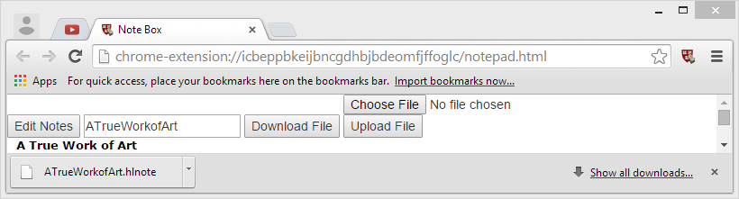

Figure 6: A True Work of Art Saved

### Uploading Notes

Similarly, if you have already downloaded a set of notes and have the **.hlnote** file handy, you may click **Choose File** to select a file and then click **Upload File** to load it into the editor.

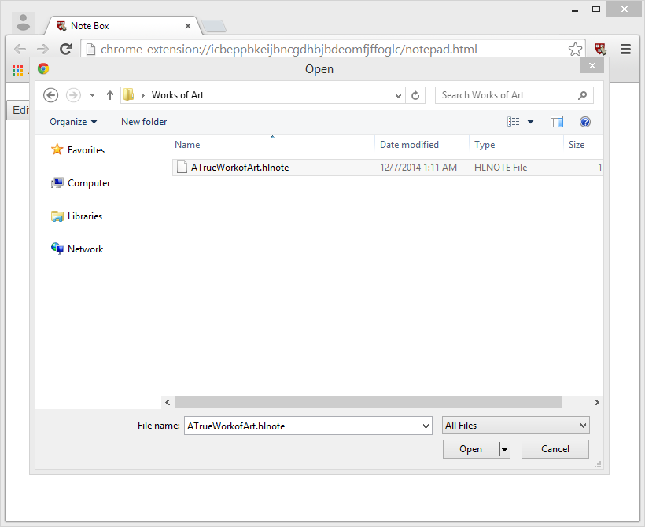

Figure 7: Choose your file and...

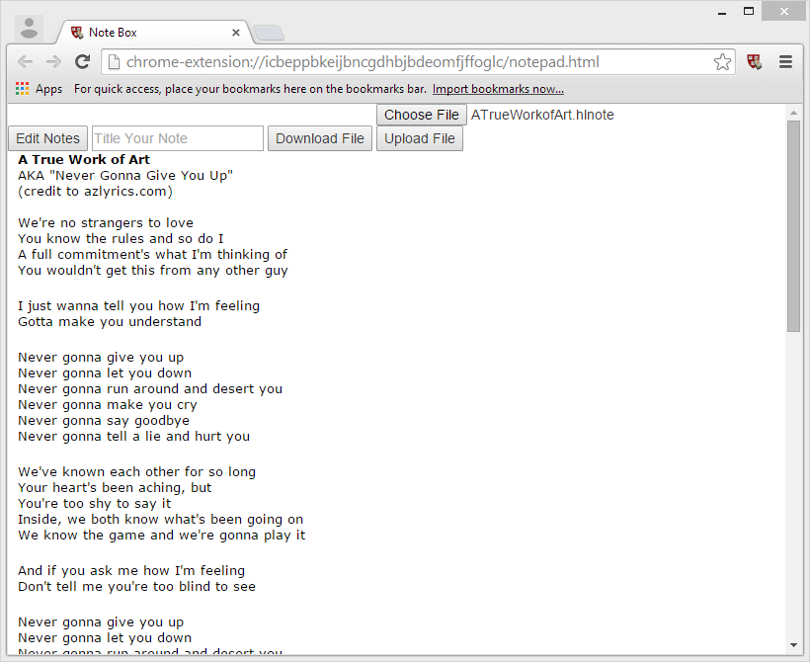

Figure 8: Voila!

## CS50 2x

The classic. The legend. The famous CS50 2x extension. Works exactly like the original. Or rather, it IS the original. Thanks to David Malan for letting us use CS50 2x!

**Important**: don’t run the embedded version and the original at the same time. We are not responsible for any holes ripped in the fabric of space-time should you decide to do so.

## Video Manipulator

Harvard Lecture Helper is reliant on CS50 2x: 2x must first be run in order to enable to advanced Video Manipulator modules. After you have 2x-ed a video on any supported site, you will be able to run the **Video Pauser** and **Video Resumer**.

Note: on YouTube, both modules will work regardless of whether CS50 2x had been previously run.

### Video Pauser

When **Get Video Time** is clicked, a dialog box with the URL will appear. You must copy the URL in order to have a time stamp. If you did not want to copy it, simply press Enter, or click Ok or Cancel to return to your webpage.

You cannot tamper with the URL generated by the **Video** **Pauser**. More specifically, do not modify the provided URL in any way.

Note: this also means that if the URL is automatically modified upon load (e.g. page redirection), this program may fail to function as expected.

### Video Resumer

The **Video Resumer** is to be used after navigating to a URL provided by the **Video Pauser**. While on such a page, click **Resume Video** to resume playback of the current video at the specified time—when you last clicked **Get Video Time**. (If you received a URL for the video at say, 2:55, playback should resume at that time as well.

Note: you may need to run CS50 2x again after navigating to the provided URL in order to resume playback properly.

### Supported Sites

Currently, Harvard Lecture Helper’s Video Manipulator supports the following domains:

* isites.harvard.edu
* youtube.com

This extension should work on most websites that use the HTML5 video tag (i.e <video src="..." ...></video>), but has not been tested on other websites, and as a result, may not work as expected or even at all. (See KNOWN BUGS below for more information!)

## Options

Right now, we only have the option to **Clear Data**, which will reset your notepad to its defaults.

**Important**: this means that you WILL lose all the notes you’ve worked so hard to take! Be careful not to clear anything you haven’t exported!

# Known Limitations/Errors

* The webpage must support additional HTTP GET methods (e.g. ...x=abc&y=123)

If it does not, the URL outputted from the video pauser will not work, and will likely break the webpage. (e.g. https://cs50.harvard.edu)

* If CS50 2x does not work, chances are this video manipulation won't work either (since in most cases CS50 2x will need to be run before the video manipulator works as well)
* Video manipulation does not currently function on webpages that use i-frames to encapsulate their videos (<iframe src="..." ...></iframe>)
* There is currently a size limitation of around 3 MB. This should not affect text-only users, but people who embed images should be warned that local storage does not function properly with larger document sizes. Importing and standard saving will not function; exporting will still work.